**1: Sisestada andmebaasi andmed ja igasse tabelisse kümme rida.**

insert into Galleries values ('Tormi', 'Male', 18, 'True')

insert into Galleries values ('Alexander', 'Male', 35, 'False')

insert into Galleries values ('Tauri', 'Male', 42, 'True')

insert into Galleries values ('Karin', 'Female', 26, 'True')

insert into Galleries values ('Külliki', 'Female', 69, 'True')

insert into Galleries values ('Toivo', 'Male', 67, 'True')

insert into Galleries values ('John', 'Male', 81, 'False')

insert into Galleries values ('Oliver', 'Male', 75, 'False')

insert into Galleries values ('Sara', 'Female', 88, 'False')

insert into Galleries values ('Tommy', 'Male', 5, 'True')

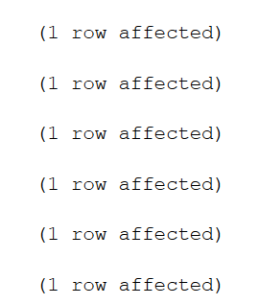

Insert into WorksOfArt values ('Golden Statue', 'True', 8, '', 2)

Insert into WorksOfArt values ('John''s Lullaby', 'True', 7, '', 4)

Insert into WorksOfArt values ('A Wicked Journey', 'False', 0, 'Astro', 3)

Insert into WorksOfArt values ('Zeus', 'True', 2, '', 2)

Insert into WorksOfArt values ('Nummi''s Story', 'True', 1, '', 3)

Insert into WorksOfArt values ('Mountains', 'True', 6, '', 1)

Insert into WorksOfArt values ('A Pot of Flowers', 'False', 0, 'Mary', 1)

Insert into WorksOfArt values ('A Song About Dinosaurs', 'False', 0, 'Trevor', 4)

Insert into WorksOfArt values ('Colormix', 'True', 10, '', 1)

Insert into WorksOfArt values ('Pillow Monster', 'False', 0, 'Wick', 2)

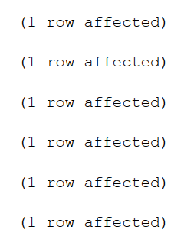

Insert into WorksOfArtGroups values ('True', 'False', 'False', 'False')

Insert into WorksOfArtGroups values ('False', 'True', 'False', 'False')

Insert into WorksOfArtGroups values ('False', 'False', 'True', 'False')

Insert into WorksOfArtGroups values ('False', 'False', 'False', 'True')

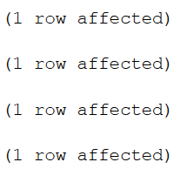

**2: Teha üks omal valikul stored procedure päring ja kutsuda see .NETi projektis esile.**

create procedure spArtistsAge0To18

as

begin

Select * from Galleries where ArtistAge <= 18

end

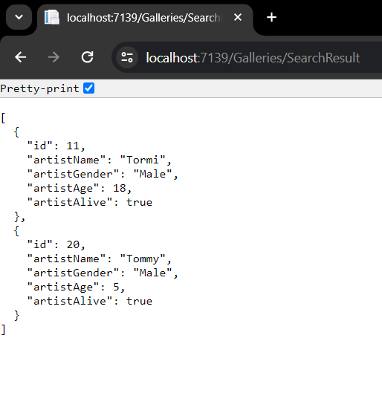

**3: Teha kolm JOIN päringut.**

select W.ID, W.WorkOfArtName, Case when W.MadeByArtistID = 0 then 'No' else 'Yes' end as MadebyArtist

from WorksOfArt W

left join Galleries G

on G.ID = W.ID

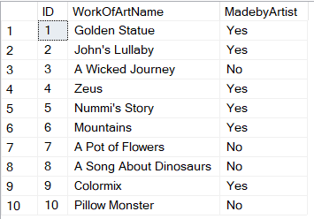

select W.ID as WorkofArtID, W.WorkOfArtName, Case when W.MadeByArtistID = 0 then 'Not made by an artist' else G.ArtistName end as ArtistName

from WorksOfArt W

left join Galleries G

on G.ID = W.MadeByArtistID

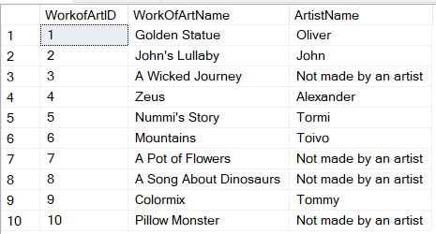

select W.ID as WorkofArtID, W.WorkOfArtName, Case when W.WorkOfArtGroup = 1 then 'Painting' when W.WorkOfArtGroup = 2 then 'Sculpture' when W.WorkOfArtGroup = 3 then 'Literature' when W.WorkOfArtGroup = 4 then 'Music' end as WorkOfArtGroup

from WorksOfArt W

left join WorksOfArtGroups G

on G.ID = W.WorkOfArtGroup

